|  |  |  |  |
| --- | --- | --- | --- |
| Version | Author(s) | Description | Date |
| 0.1 | John DeSalvo | Initial Draft | 08/21/2023 |
| 0.2 | John DeSalvo | Setting mode initial, update to Instruction keyboards and recipe creation | 01/17/2024 |
| 0.3 | John DeSalvo | Change password keypad, change how Back button functions in expanded menu selection.  Change keyboard, Added initial Service options for T1  Added Water Fill process (more process needed)  Revamping Recipe Running scenarios.  Service mode Entering Model and Serial number.  Cookbook properties Import and Export json file. | 03/27/2024 |
| 0.4 | John DeSalvo | Added additional Setting mode items.  Added Water Fill processes (Eclipse only) | 04/03/2024 |
| 0.5 | John DeSalvo | Many changes to UI layouts and functions | 08/19/2024 |
| 1.0 | John DeSalvo | Total Re-write as UI functionality and layouts for numerous additional models and features has occurred | 04/01/2025 |

Table of Contents

1.0 PURPOSE 4

2.0 SCOPE 4

3.0 REFERENCE DOCUMENTS 4

4.0 GLOSSARY 4

5.0 GENERAL UI REQUIREMENTS 5

5.1 UI Button Functionality 5

5.2 Recipe Stages 5

5.3 Numeric Keypads 5

5.3.1 Time keypad 5

5.3.2 Target Temp keypad 6

5.3.3 Probe Temp keypad 6

5.3.4 Probe Time keypad 7

5.3.5 Password keypad 7

5.3.6 Configure Hysteresis & Offsets keypads 8

5.3.7 Configure Pan, Product, or Convection PID keypads 8

5.4 Alpha Numeric Keyboards 9

6.0 HOME SCREEN 10

6.1 Chef Hat 10

6.2 Press & Go 11

6.3 Settings 11

6.4 Cookbook 11

6.5 Pan Buttons 12

6.6 Water Fill Button 12

6.7 Lid Buttons 13

7.0 RECIPE CREATION (CHEF HAT) 14

7.1 Timed Cooking Stage Creation 16

7.2 Probe Cooking Stage Creation 16

7.3 Probe + Time Cooking Stage Creation 16

7.4 Infinity Cooking Stage Creation 16

7.5 Convection Cooking Stage Creation 16

8.0 RECIPE OPERATION PROCESS 17

8.1 Timed Cooking 17

8.2 Probe Cooking 18

8.3 Probe + Timed Cooking 20

8.4 Infinity Cooking 20

8.5 Convection Cooking 21

9.0 PRESS & GO COOKBOOK 22

9.1 EDIT button 22

9.2 HOME button 22

9.3 TRASH CAN button 22

9.4 START button 22

10.0 SETTINGS 23

10.1 Unit details 23

10.2 General settings 23

10.2.1 Language 23

10.2.2 Units of measure 24

10.2.3 Date/Time 24

10.2.4 Display 25

10.2.5 Sound 26

10.3 Network 26

10.3.1 Ethernet/LAN 26

10.3.2 Wi-fi 27

10.3.3 Kitchenconnect 27

10.4 Logbook 27

10.4.1 Error Logs 28

10.4.2 Event Logs 28

10.4.3 HACCP viewer 29

10.4.4 Export HACCP Data 29

10.5 Diagnostics 29

10.6 Legal information 29

10.7 Service 29

10.7.1 Unit model number 29

10.7.2 Serial number 30

10.7.3 Configure parameters 30

10.7.4 Update Io Firmware 30

10.8 Cookbook 30

10.8.1 Cookbook properties 30

10.8.2 Manage Cookbook 31

10.8.3 Import Cookbook 31

10.8.4 Export Cookbook 31

11.0 MAIN COOKBOOK 32

12.0 ERRORS 33

# PURPOSE

This document shall specify UI software requirements for the new Cleveland Range Common UI Models. Differences between models shall not be annotated in this document. Cleveland provided documentation shall describe each model’s configured functions and applicability. This document shall describe each function and layout.

# SCOPE

Cleveland Range has provided a story board Power Points, Flowcharts and Excel spreadsheets to describe basic functions and UI flow and error handling characteristics. Those documents should be used to outline each model’s characteristics.

Using those documents, this specification shall provide screen shots of a of the UI created by ELREHA. The included simulation screenshots and/or visual representations depicted throughout this specification may not be the final layout in the firmware as adjustments may be requested by Cleveland.

This document shall further detail the software requirements of the UI.

# REFERENCE DOCUMENTS

Documentation describing each unit’s functionality shall be available on Cleveland’s Dev Ops Repository and shall consist of Flow Charts, Power Point for general UI layout, and Modbus specification regarding UI and IO operations.

# GLOSSARY

|  |  |
| --- | --- |
| Acronym | Definition |
| UI | User Interface |
| IO | Input Output (hardware control) |

# GENERAL UI REQUIREMENTS

## UI Button Functionality

A button action shall either be a press and release or a press and hold.

* A press and release button action shall be implemented on the release of the button. If applicable, any modBus command sent to the IO board is sent upon release.
* A press and hold button action shall be implemented so long as the button is in a hold state. If applicable, any modBus command sent to the IO board is sent so long as the button is held.
* When any enabled button is depressed, the button shall be highlighted.
* For buttons that select an item such as a recipe, upon release the highlighted button shall remain on the screen.
* Disabled buttons shall be greyed out indicating its function is not available.

## Recipe Stages

A Recipe stage shall utilize a cooking mode and perform until its defined conditions have been completed or it shall be a message where a user is prompted to perform some action before further advancing in the recipe process.

* There are several types of cooking modes that can be utilized by the user in a recipe stage (see Section 7).
* A recipe stage with a message is a user created instruction that shall provide information to a user and require user acknowledgement prior to proceeding to the next stage.
* A non-message stage (i.e., cooking stage) upon completion shall proceed to the next stage without user action.
* A recipe shall have a maximum of 12 defined stages.
* A recipe shall consist of any combination of cooking modes or messages up to the maximum.

## Numeric Keypads

Numeric user defined entry values shall require a numeric keypad for user data entry.

### Time keypad

The keypad displayed for a cook stage time data shall use the following or similar design:

**Figure 1**

* Time information entered on the UI should be displayed and shifted in as hours and minutes as the user enters data.
* The Clear button would delete all data from the display.
* The --:-- key shall immediately display --:-- (used as Infinity time) in the display and no further entry other than Clear can be entered.
* The Green Check Mark confirms the user input.
* The “X” cancels the data entry and returns to previous screen.
* If an invalid value is entered and Check Mark pressed, the display shall show INVALID.
* Valid entries for time shall be 0 – 99 HRS : 0 – 59 MINS with a minimum time of 1 minute (00:01).

### Target Temp keypad

The keypad displayed for a cook stage Target Temp data shall use the following or similar design:

**Figure 2**

* Target Temp information entered on the UI area should be displayed and shifted in as the user enters data.
* The Clear button would delete all data from the display.
* The Green Check Mark confirms the user input.
* The “X” cancels the data entry and returns to previous screen.
* If an invalid value is entered and Check Mark pressed, the display shall show INVALID.
* Valid entries for temperature shall be 50 – 425 °F (UI shall convert to Celsius if unit configured for Metric)

### Probe Temp keypad

The keypad displayed for a cook stage Probe Temp data shall use the following or similar design:

**Figure 3**

* Probe Temp information entered on the UI area should be displayed and shifted in as the user enters data.
* The Clear button would delete all data from the display.
* The green CHECK MARK button confirms the user input.
* The “X” button cancels the data entry and returns to previous screen.
* If an invalid value is entered and Check Mark pressed, the display shall show INVALID.
* Valid entries for temperature shall be 50 – 212 °F (UI shall convert to Celsius if unit configured for Metric)
* The Time button shall open an additional Probe Time keypad.

### Probe Time keypad

The keypad displayed for a cook stage Probe Time data shall use the following or similar design:

**Figure 4**

* Probe Time information entered on the UI should be displayed and shifted in as hours and minutes as the user enters data.
* The Clear button would delete all data from the display.
* The --:-- key shall immediately display --:-- (used as Infinity time) in the display and no further entry other than Clear can be entered.
* The Green Check Mark confirms the user input.
* The “X” cancels the data entry and returns to previous screen.
* If an invalid value is entered and Check Mark pressed, the display shall show INVALID.
* Valid entries for time shall be 0 – 99 HRS : 0 – 59 MINS with a minimum time of 1 minute (00:01).

### Password keypad

The keypad displayed for entering passwords accessed by pressing the Chef icon in Settings mode shall use the following or similar design:

**Figure 5**

* Password entered on the UI should be displayed and shifted in as the user enters data.
* The Clear button would delete all data from the display.
* The Green Check Mark confirms the user input.
* The “X” cancels the data entry and returns to previous screen.
* If an invalid value is entered and Check Mark pressed, the display shall show INVALID.

### Configure Hysteresis & Offsets keypads

The keypads displayed for entering the Hysteresis, Jacket Offset and Product Offset can be accessed in Service🡪Configure Parameters🡪Configure Hysteresis & Offset and shall use the following or similar designs:

**Figure 6 Figure 7 Figure 8**

* Hysteresis or Offset information entered on the UI area should be displayed and shifted in as the user enters data.
* The Clear button would delete all data from the display.
* The Green Check Mark confirms the user input.
* The “X” cancels the data entry and returns to previous screen.
* If an invalid value is entered and Check Mark pressed, the display shall show INVALID.

### Configure Pan, Product, or Convection PID keypads

The keypads displayed for entering the Pan mode PID, Product mode PID or Convection mode PID can be accessed in Service🡪Configure Parameters🡪Configure pan mode PID or Configure product mode PID or Configure convection mode PID and shall use the following or similar designs for P, I, and D data:

**Figure 9**

* PID information entered on the UI area should be displayed and shifted in as the user enters data.
* The Clear button would delete all data from the display.
* The Green Check Mark confirms the user input.
* The “X” cancels the data entry and returns to previous screen.
* If an invalid value is entered and Check Mark pressed, the display shall show INVALID.

## Alpha Numeric Keyboards

Keyboards to enter alpha-numeric data such as recipe name, cook stage messages, unit serial number or Cookbook name shall use the following or similar designs with additional characteristics based upon keyboard usage.

**Figure 10 Figure 11 Figure 12 Figure 13**

**Input Limitations**

* The input limitations for Recipe Name shall be 2 lines with a maximum of 10 characters per line. (Figure 10)
* The input limitations for Message entry shall be 4 lines with a maximum of 20 characters per line. (Figure 11)
* The input limitations for Serial Number entry shall be 1 line with a maximum of 20 characters per line. (Figure 12)
* The input limitations for Cookbook name entry shall be 1 line with a maximum of 10 characters per line. (Figure 13)
* After an input value is entered by the user the Greyed Check Mark turns green and pressing the Green Check Mark confirms the user input
* The “X” cancels the data entry and returns to previous screen.

# HOME SCREEN

The HOME screen buttons shall provide the user access to various functions or features as described below.

Note: Any of the lower row of buttons may or may not be displayed depending upon the model. See the Cleveland document defining model features (Revision-Model numbers and features).

**Figure 14**

Buttons shall be disabled or greyed out on the Home screen if certain conditions exist as described:

* If user tilts the pan (IO reported), the **Press&Go** and **COOKBOOK** buttons shall be disabled. If user presses either button, a pop-up message is displayed: “Attention Checking pan status, this functionality available when pan is down”
* If user tilts the pan (IO reported),the bottom buttons **WATER FILL**, **LID DOWN** and **LID UP** are greyed out and disabled.
* If user tilts the pan (IO reported) and presses the **CHEF HAT** button, in the recipe creation screen the **START** button is greyed out until the pan is down.
* If user closes lid (IO reported), the bottom **PAN DOWN**, **PAN UP** and **WATER FILL** buttons are greyed out and disabled.

## Chef Hat

The **CHEF HAT** button provides access to recipe creation screen(s). The following or similar design shall be displayed upon a user pressing the **CHEF HAT** button.

**Section 7** shall describe the functionality of the Recipe creation feature.

**Figure 15**

## Press & Go

The **Press&Go** button provides the user access to a limited list of Favorite recipes. The following or similar design shall be displayed upon the user pressing the Press&Go button.

**Section 9** shall describe the functionality of the Press&Go feature.

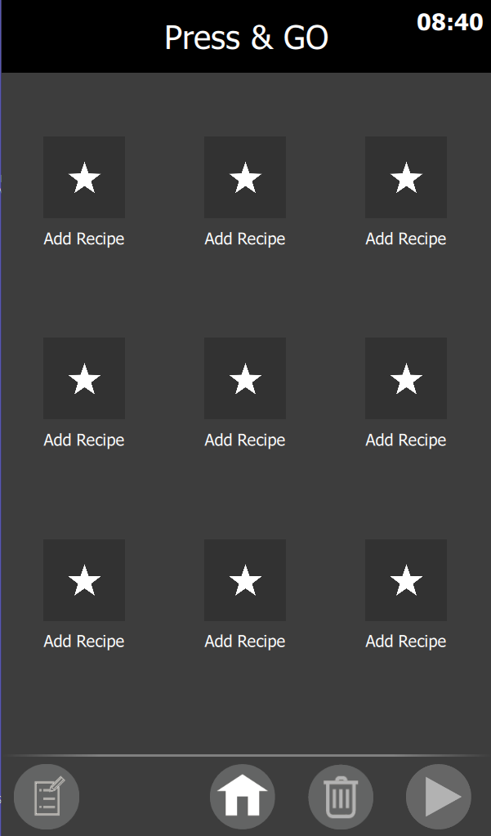  
**Figure 16**

## Settings

The **SETTINGS** button provides the user access to Settings mode as well as the button to access the password protected modes of Service and Cookbook. The following or similar design shall be displayed upon the user pressing the **SETTINGS** button.

**Section 10** shall describe the functionality and access requirements for all the modes.

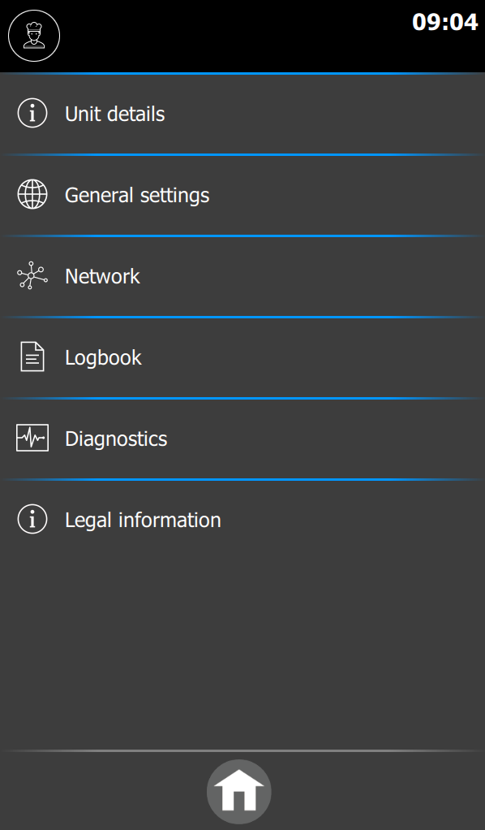

**Figure 17**

## Cookbook

The **COOKBOOK** button provides the user access to Master List of recipes stored in UI memory. The following or similar design shall be displayed upon the user pressing the **COOKBOOK** button.

**Section 11** shall describe the functionality of the Cookbook feature.

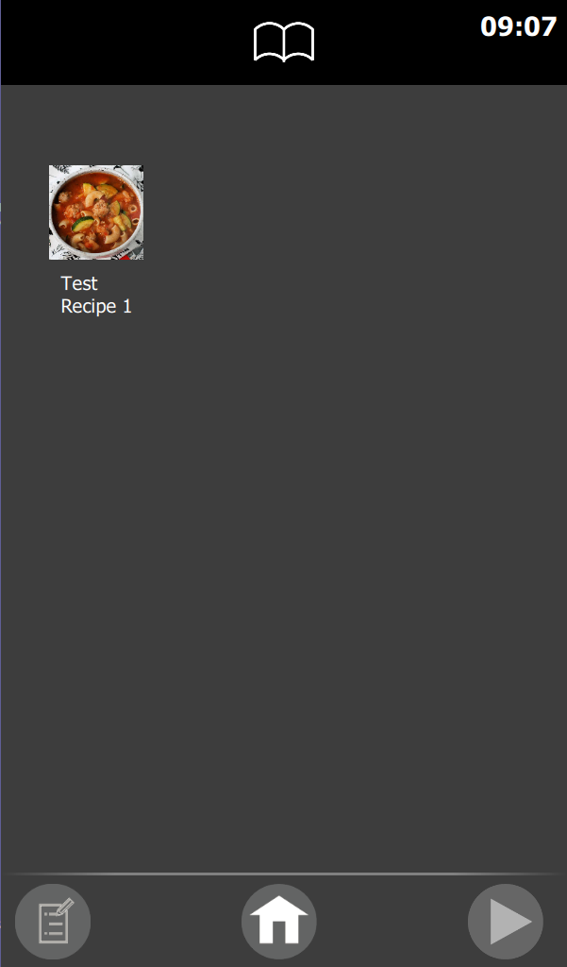

**Figure 18**

## Pan Buttons

* The two (2) lower left PAN buttons shall provide the user with the ability to Level or Tilt the Pan.
* While in the Home screen, the UI shall monitor the pan status received from the IO board.
* The user pressing and holding the **PAN UP** (tilt) button shall invoke a UI modBus command to raise the pan.
* Upon pressing the **PAN UP** button the UI shall disable the **Press&Go**, **COOKBOOK**, **WATER** **FILL**, and both LID buttons for 3 seconds allowing time for the IO board to report status of the Pan.
* Upon the IO board reporting the pan is not at a level position, the UI shall continue to disable all these buttons.
* The user pressing and holding the **PAN DOWN** (level) button shall invoke a UI modBus command to lower the Pan.
* Upon the IO board reporting the Pan is at the Level position, the UI shall Enable all Home buttons.
* Upon a user releasing either button, the UI shall send a stop modBus command to the IO board for PAN movement.

## Water Fill Button

Pressing the **WATER FILL** button on the Home screen provides user access to configure and add water to the unit.

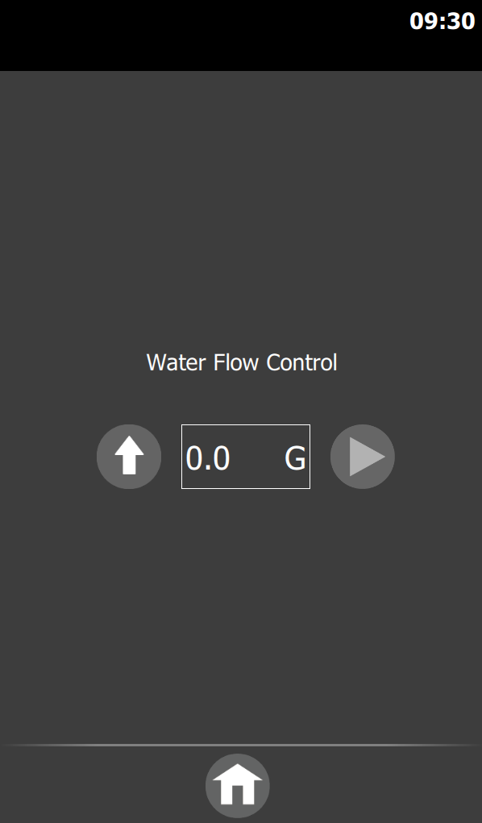 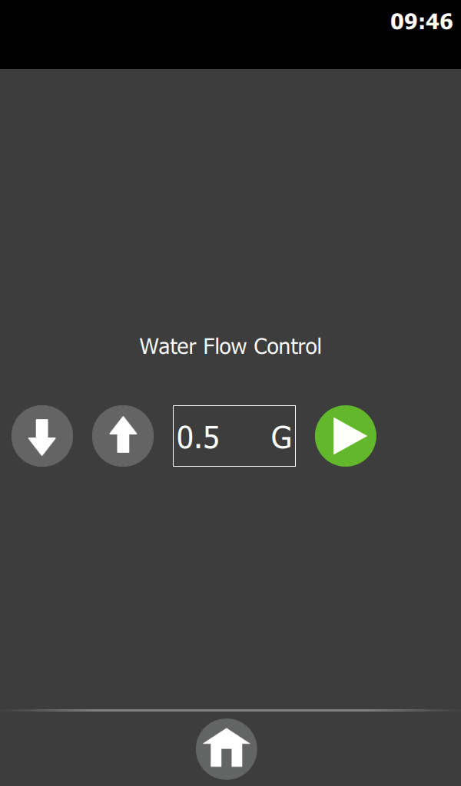 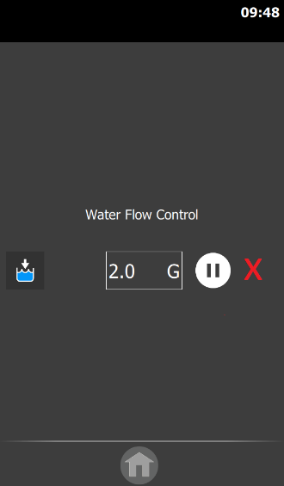 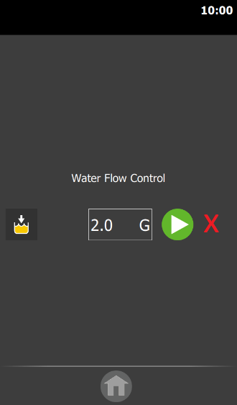

**Figure 19 Figure 20 Figure 21 Figure 22**

**NOTE:** the allowable water filling range is determined by model number (0 to 30 or 0 to 40 gallons or Liter equivalent)

**Initial Water Flow Control screen (Figure 19)**

UI shall provide the Water Flow Control screen which consists of

* an **UP-ARROW** button allowing users to increase water amount by 0.5 gallon or metric equivalent increments.
* a DISPLAY BOX showing current water fill value in G (gallons) or L (liters)
* a greyed out disabled **START** button.
* a HOME button at bottom of screen to cancel Water Fill process and return to HOME screen.

**User amount adjustment screen (Figure 20)**

* upon entering a non-zero water fill value an additional **DOWN-ARROW** button is displayed for decrementing the water fill value
* the **START** button is green, allowing the user to start the water filling process.
* HOME button is still enabled allowing the user to cancel Water Fill process and return to HOME screen.

**User selects to Start Water Fill (Figure 21)**

* Upon starting the water filling process, the **HOME** button is greyed out and disabled.
* The green **START** button is replaced with a **PAUSE** button and **STOP** button to the right of the DISPLAY BOX
* On the left side a graphic of a blue-filled kettle indicates the water filling process is active.
* The UI shall send modBus commands to the IO for water filling to start and the amount to fill.
* The UI shall monitor IO for the current amount remaining water amount and update the DISPLAY BOX

**User selects Pause Water Fill (Figure 22)**

* If the user presses the **PAUSE** button a yellow-filled kettle is displayed
* The **PAUSE** button is replaced with a green **START** button to resume the water filling process.
* In addition, at the **PAUSE** button press, the UI sends a modBus commands to the IO for water filling to stop.
* If the user presses the **START** button to resume the water filling process, the UI shall send a command to IO to start the water filling process.

**User selects to STOP Water Fill (Figure 22)**

* If a user presses the **STOP** button, the screen returns to the initial entry screen.
* The UI sends modBus comments to stop the water filling process and a 0-value amount to indicate to IO the water filling process has been cancelled.

## Lid Buttons

The two (2) lower right buttons shall provide the user with the ability to Close or Open the Lid.

**LID button functionality**

Upon the user pressing and holding a Lid button, the corresponding command shall be sent via modBus to the IO board.

See Section 6.0 HOME SCREEN for availability of LID buttons.

# RECIPE CREATION (CHEF HAT)

The Recipe Creation screen (see **Figure 15**) shall be accessed by pressing the Home screen **CHEF HAT** button.

A recipe can have multiple stages using any or are all the cooking methods described in sections 7.1 through 7.5. Transitioning from one stage to the next shall require the UI to update the IO board via Modbus the cooking/heating instructions for the IO to cook accordingly.

**TEMP button**

* Pressing the **TEMP** button or inside the temperature display area shall display a TARGET TEMP keypad (see **Figure 2**).
* The TARGET TEMP keypad allows users to define the jacket setpoint for this stage of the recipe.

**MESSAGE button**

* Pressing the **MESSAGE** button shall display a keyboard labeled “Message Text” with an X button to cancel and a greyed-out **CKECK MARK**. (see **Figure 11**)
* After a valid Message is entered the greyed-out CKECK MARK shall be replaced by a green CHECK MARK.
* Entering a message and pressing the green **CHECK MARK** adds a message stage to the new recipe being created.

**CLOCK button**

* Pressing the **CLOCK** button shall display a TIME keypad (see **Figure 1**).
* Pressing inside the display area located between the CLOCK and PROBE icons with the CLOCK icon highlighted shall open the TIME keypad.
* The TIME keypad shall allow users to define the length of cooking time for this stage of the recipe.

**PROBE button**

* Pressing the **PROBE** button shall open a PROBE TEMP keypad (see **Figure 3**)
* Pressing inside the display area located between the CLOCK and PROBE buttons with the PROBE button highlighted shall open the PROBE TEMP keypad.
* The PROBE TEMP keypad shall allow users to define the probe temp target for this stage of the recipe.
* With the PROBE TEMP keypad displayed an additional **CLOCK** button when pressed shall display the PROBE TIME keypad (see **Figure 4**).
* With a valid Probe Time entered and the green **CHECK MARK** pressed, the recipe creation screen shall have an additional row displaying that value below the Probe Temp value. Buttons below are shifted downward to allow this new row to be displayed.

**FAN button**

* The **FAN** button cycles the Fan operation with each press (Convection cooking) between 3 states: OFF, LOW and HIGH.   
  Off is characterized by a greyed-out **FAN** button with 2 greyed-out indicator lights to the right.  
  Low is characterized by a highlighted **FAN** button with 1 side indicator light On green (lower light).  
  High is characterized by a highlighted FAN button with both side indicator lights On green.
* The default for the Fan operation in a stage shall be Off.

**SV button**

* The **SV** button (Sous vide) defaults to greyed out for each cooking stage.
* Pressing the **SV** button highlights the button.
* Pressing a highlighted **SV** button, greys out the button.
* The UI shall send the Modbus sous vide state to the IO for each stage.

**START button**

* The recipe Creation screen shall display a Greyed-out and disabled **START** button if pan is not down.
* The enabled green **START** button shall be displayed if the pan is down.
* Pressing the green **START** button shall start the current recipe.

**TRASH CAN button**

* Pressing the **TRASH CAN** button shall delete the current stage displayed.
* The **TRASH CAN** button is greyed out in Stage 1 not allowing it to be deleted.

**< > buttons**

* Pressing the **<** button shall display the previous stage if UI is currently displaying a stage greater than the first stage. If the first stage is displayed the < icon button is greyed out and disabled.
* Pressing the **>** button shall create and display an additional new stage or an existing next stage if already defined up to the maximum allowable stages (see **5.2 Recipe Stages**)
* Located between **<** and **>** buttons shall be the current stage displayed / total of recipe stages.

**+ button**

* The **+** button shall open a screen with 2 selectable buttons for adding a **Cooking Step** or **Message Step** as well as an **X** button to cancel the selected action.
* Pressing the add **Cooking Step** button opens the recipe creation screen with a new stage for user input.
* Pressing the add **Message Step** button opens a Message area and a keyboard for text instruction entry.

**SAVE button**

* Pressing the **SAVE** button shall display a keyboard labeled “Enter Recipe Name” with an **X** button to cancel and a greyed-out **CKECK MARK**. (see **Figure 10**)
* After a valid Recipe Name is entered the greyed-out **CKECK MARK** shall be replaced by a green **CHECK MARK**.
* Users pressing the green **CHECK MARK** displays a screen with:   
  **BACK ARROW**  
  Greyed-out **CHECK MARK**  
  Available recipe images  
  or a **USB** button on the bottom to select an image from a USB stick.
* Upon the user selecting an image the **CHECK MARK** shall be green and enabled.
* Pressing the Green **CHECK MARK** saves the recipe in the Main Cookbook and displays the Last stage information.
* Any recipe that has been saved shall display the recipe name and icon at top of every stage screen.
* Any recipe that has not been saved, shall not display any name or icon at the top of the recipe stage screens.

**WATER FILL button**

* Pressing the **WATER FILL** button removes that button from the recipe creation screen but adds to the right the following:  
  An **UP-ARROW** button allowing user to increase water amount in 0.5 gallon or metric equivalent increments  
  A DISPLAY BOX showing current water fill value in G (gallons) or L (liters)  
  A greyed out disabled **START** button  
  A **X** button to Cancel
* Pressing the **UP-ARROW** shall add a **DOWN-ARROW** to decrease the water filling value and the **START** button is now green and enabled.
* Pressing the **X** button shall revert the screen to show only the original **WATER FILL** button and cancel the water filling process.
* Pressing the green **START** button sends the appropriate Modbus commands to IO board (Start water fill and amount)
* The UI monitors IO board and updates water fill value as reported.
* Pausing or stopping the Water Fill process will function the same as described in 6.6 Water Fill
* The in-progress Water filling row of buttons shall be displayed on all recipe creation screens to allow users to control the process.

**PAN DOWN / PAN UP buttons**

* Pressing the **PAN DOWN** or **PAN UP** buttons shall invoke the UI to send the appropriate command to the IO board.
* The UI shall monitor Pan status from the IO board.
* If the IO board reports Lid in Full Down, the UI shall grey out and disable the **START** button.

**HOME button**

* Pressing the **HOME** button displays the UI Home screen (see **Figure 14**) and deletes all unsaved recipe information.

**LID OPEN / LID CLOSE buttons**

* Pressing the **LID OPEN** or **LID CLOSE** buttons shall invoke the UI to send the appropriate command to the IO board.
* The UI shall monitor Lid status from the IO board.
* If the IO board reports Lid Closed down (100% down) and users press the **START** button, if the starting stage is not a Convection mode cooking stage, the UI shall send the appropriate commands to open the Lid 10%.

## Timed Cooking Stage Creation

A user defined Timed Cooking Stage operates for a specified time and target temperature.

To create a valid Timed Cooking Stage in the Recipe Creation screen, the user must:

* Press the **TEMP** button and enter a valid Target Temperature. (see **Figure 2**)
* Press the **CLOCK** button and enter a valid Time (see **Figure 1**)

A Timed Cooking Stage shall run as either a standalone recipe or as one stage in a multiple stage recipe.

## Probe Cooking Stage Creation

A user defined Probe Cooking Stage operates until a Probe sensor reaches a user defined temperature value.

To create a valid Probe Cooking Stage in the Recipe Creation screen, the user must:

* Press the **TEMP** button and enter a valid target temperature.
* Press the **PROBE** button and enter a valid Probe Temperature (see **Figure 3**)

A Probe Cooking Stage shall run either as a standalone recipe or as one stage in a multiple stage recipe.

## Probe + Time Cooking Stage Creation

A user defined Probe + Time Cooking Stage operates until both conditions are met. First the Probe sensor must reach a user defined probe temperature value and then the timed portion of the stage must expire.

To create a valid Probe + Time Cooking Stage in the Recipe Creation screen, the user must:

* Press the **TEMP** button and enter a valid target temperature.
* Press the **PROBE** button and enter a valid Probe Temperature
* Press the **CLOCK** button in the PROBE TEMPERATURE keypad and enter a valid Time (see **Figure 4**)

A Probe + Time Cooking Stage shall run as either a standalone recipe or as one stage in a multiple stage recipe.

## Infinity Cooking Stage Creation

A user defined Infinity Cooking Stage operates at a target temperature for an unlimited time.

To create a valid Infinity Cooking Stage in the Recipe Creation screen, the user must:

* Press the **TEMP** button and enter a valid target temperature)
* Press the **CLOCK** button and select the --:-- button on the keypad)

An Infinity Cooking Stage shall run as either a standalone recipe or as the last stage in a multiple stage recipe.

## Convection Cooking Stage Creation

A user defined Convection Cooking Stage can be either a timed, probe, probe + time or infinity stage with the addition of a Convection fan being utilized. Creating any of these cooking stages are identical to the steps above with the addition of selecting Fan On either LOW or HIGH.

# RECIPE OPERATION PROCESS

An operational Recipe shall start either through:

* Manual Creation of a recipe (see **Section 7**) or
* Selecting a recipe from Main Cookbook (see **Section 11**)
* Selecting a recipe from Press&Go (see **Section 9**)

## Timed Cooking

When a Timed Cooking stage starts, the UI shall send a Target Temperature value and cooking method to the IO Board via modBus. The UI is responsible for tracking the time and when it expires either transition to the next stage or if the recipe is complete send a Modbus commands to IO to stop the heating process.

**Timed Cooking Preheat**

* If the first stage is a Timed cooking stage, a PREHEAT screen is displayed displaying a progress wheel for temperature to reach the Target Temp (see **Figure 23**).
* During Preheat the LID Buttons are operable, but the UI will NOT allow the LID to close 100% and when IO reports 90% closed the UI will discontinue sending close commands to IO via modBus.
* During Preheat the **Pan UP** button if pressed shall issue a message stating “This will pause the recipe are you sure?”.  
  If user presses the **X** button no action is taken.  
  If user presses the **CHECK MARK** button the **PAN UP** button is enabled and a further press and hold of the **PAN UP** button the UI shall send commands to IO to tilt pan up (Note: IO shall disable heating while pan is not fully down).  
  If user presses **PAN DOWN** button and IO detects the pan is down, the preheating process shall resume and the progress bar shall again be active.
* During Preheat the **LID UP** and **LID DOWN** buttons are enabled, and if pressed the appropriate commands are sent to the IO board through modBus. However, if the IO board reports Lid down 90%, the UI shall send no further lid down commands to IO.   
  If Lid was down 100% when entering Preheat stage, the UI shall send commands to open the lid 10%.
* During Preheat the **WATER FILL** button is enabled, and if pressed, the water filling process shall start. See **Section 7.0** for the water filling process described in Recipe creation as the process and functionality shall be identical.
* During Preheat the red **STOP** button is enabled, and if pressed a pop-up message is displayed stating “This will stop the recipe, are you sure?”.  
  If users press the **X** button, no action is taken.  
  If users press the **CHECK MARK** the recipe is stopped and appropriate modBus commands are sent to the IO to stop the heating process.
* If the Preheat is completed a screen stating PREHEAT COMPLETE is displayed and the Red STOP button is replaced with a green **CHECK MARK** allowing the users to start the timed cooking stage (see **Figure 24**)
* If sound is enabled for Message Displayed, it shall activate when PREHEAT COMPLETE is displayed.

**Figure 23 Figure 24**

**Timed Cooking Stage**  
Whether transitioning to a Timed Cooking Stage from Preheat or another cooking stage, the operation is the same (see **Figure 25**)

* At start of a Timed Cooking Stage the appropriate Modbus commands are sent to the IO board.
* In the Timed Cooking Stage screen upper left corner, a Temperature icon is displayed, and to its right in the middle top area the Target Setpoint temperature is displayed.
* In the middle a large circular progress wheel represented with a yellow band depicting time progression.
* Inside the progress wheel a countdown timer of the stage time remaining shall be displayed.
* To the upper left of the progress wheel is a Clock icon with the total stage time shown.
* Below the progress wheel the current recipe stages are displayed with the current active stage yellow-filled, completed stages green-filled (if applicable), and subsequent stages grey-filled (if applicable).
* The PAN and LID buttons operate the same as in **Timed Cooking Preheat** described above with the exception that if the **PAN UP** button causes the stage to Pause, the timer progress wheel and timer shall be paused. Only when the Pan is down shall the timer resume.
* The **WATER FILL** button operates the same as in the **Timed Cooking Preheat** described above.
* The red **STOP** button operates the same as in the **Timed Cooking Preheat** described above.

**Figure 25 Figure 26**

Upon the expiration of the Timed Cooking Stage, the UI shall automatically move to the next stage with this stage green-filled in any subsequent stage depictions.

If no additional stages are defined, the recipe Done screen shall be displayed and if sound for Recipe Finish is enabled, the sound shall activate (see **Figure 26**).

## Probe Cooking

When a Probe Cooking Stage starts, the UI shall send a Target Temperature value, Probe Temperature value and cooking method to the IO Board via modBus. The UI is responsible for monitoring the IO board Probe Temperature reported value to determine when the Probe Temp stage is completed.

There is no Probe Preheat stage. The IO board determines the heating cycle while the UI simply monitors the IO returned Probe temperature.

**Probe Cooking Stage**

Whether transitioning from another cooking stage or the Probe Cooking Stage is the first stage, the operation is the same (see **Figure 27**)

* At start of a Probe Cooking Stage the appropriate Modbus commands are sent to the IO board.
* In the Timed Cooking Stage screen upper left corner, a Temperature icon is displayed, and to its right in the middle top area the Target Setpoint temperature is displayed.
* To the left of the progress wheel is a Probe icon with target probe temperature displayed under the icon.
* In the middle a large circular progress wheel represented with a yellow band depicting progression to target probe temperature.
* Inside the progress wheel the current Probe temperature shall be displayed.
* Below the progress wheel the current recipe stages are displayed with the current active stage yellow-filled, completed stages green-filled (if applicable), and subsequent stages grey-filled (if applicable).
* During a Probe Cooking Stage, the **Pan UP** button if pressed shall issue a message stating “This will pause the recipe are you sure?”.  
  If user presses the **X** button no action is taken.  
  If user presses the **CHECK MARK** button the **PAN UP** button is enabled and a further press and hold of the **PAN UP** button the UI shall send commands to IO to tilt pan up (Note: IO shall disable heating while pan is not fully down).  
  If user presses **PAN DOWN** button and IO detects the pan is down, the process shall resume and the progress bar shall again be active.
* During a Probe Cooking Stage, the **LID UP** and **LID DOWN** buttons are enabled, and if pressed the appropriate commands are sent to the IO board through modBus. However, if the IO board reports the Lid down 90%, the UI shall send no further lid down commands to IO.  
  If the Lid was down 100% when entering the Probe Cooking Stage, the UI shall send commands to open the lid 10%.
* During a Probe Cooking Stage, the **WATER FILL** button is enabled, and if pressed, the water filling process shall start. See **Section 7.0** for the water filling process described in Recipe creation as the process and functionality shall be identical.
* During a Probe Cooking Stage, the red **STOP** button is enabled, and if pressed a pop-up message is displayed stating “This will stop the recipe, are you sure?”.  
  If users press the **X** button, no action is taken.  
  If users press the **CHECK MARK** the recipe is stopped and appropriate modBus commands are sent to the IO to stop the heating process.

**Figure 27**

Upon the IO reporting the Probe Temperature value of the Probe Cooking Stage has been attained, the UI shall automatically move to the next stage with this stage green-filled in any subsequent stage depictions.

If no additional stages are defined, the recipe Done screen shall be displayed and if sound for Recipe Finish is enabled, the sound shall activate (see **Figure 26**).

## Probe + Timed Cooking

A Probe + Timed Cooking Stage functions the same as a Probe Cooking Stage with the addition of an added step before completion.

When a Probe + Timed Cooking Stage starts, the UI shall send a Target Temperature value, Probe Temperature value and cooking method to the IO Board via modBus. The UI is responsible for monitoring the IO board Probe Temperature reported value to determine when the Probe Temp Value has been attained.

When the IO reports the Probe Temperature value has been attained, the UI transitions to an added timed step.

* At start of a Probe + Timed Cooking Stage the appropriate Modbus commands are sent to the IO board.
* The Probe + Timed Cooking Stage operates exactly like the Probe Cooking Stage until the Probe Temperature value has been attained.
* Once the IO reports the Probe Temperature value has been attained the UI screen transitions to a Timed screen (see **Figure 28**)
* In the Probe + Timed Cooking Stage screen upper left corner, a Temperature icon is displayed, and to its right in the middle top area the Target Setpoint temperature is displayed.
* To the left of the progress wheel is a Probe icon with:   
  Target Probe Temperature and below Total Stage Time.
* In the middle a large circular progress wheel represented with a yellow band depicting Timed progression until completion.
* Below the progress wheel the current recipe stages are displayed with the current active stage yellow-filled, completed stages green-filled (if applicable), and subsequent stages grey-filled (if applicable).

**Figure 28**

Upon the expiration of the Probe + Timed Cooking Stage timer, the UI shall automatically move to the next stage with this stage green-filled in any subsequent stage depictions.

If no additional stages are defined, the recipe Done screen shall be displayed and if sound for Recipe Finish is enabled, the sound shall activate (see **Figure 26**).

## Infinity Cooking

When an Infinity Cooking Stage starts, the UI shall send a Target Temperature value and cooking method to the IO Board via modBus. The Infinity Cooking stage shall always be the last stage of a recipe and shall only be completed upon the user selecting the red **CANCEL** button to stop the recipe.

* The Infinity Cooking Stage operates like the Timed Cooking Stage except for the time is infinity and depicted in the progress wheel as --:-- (see **Figure 29**).

**Figure 29**

## Convection Cooking

A Convection Cooking stage shall operate the same as the Recipes described in sections 8.1 – 8.4 with addition of a Fan on Low or High. Convection cooking requires the Lid to be closed.

* Prior to a Convection Cooking stage, the UI shall display a pop-up screen with the instruction to “CLOSE AND LOCK COVER” along with an image of an open LID over Kettle and arrow pointing down (see **Figures 30 – 31**).
* **LID UP** and **LID DOWN** when pressed shall send the appropriate command to IO board.
* The user shall be required to press the Close button (if not done already) to Close the Lid 100%.
* Upon the IO board via modBus reporting the Lid is Closed, the UI shall display a pop-up screen with the message “COVER CLOSED AND LOCKED” along with an image of a closed LID over Pan. (see **Figures 32 – 33**)
* The CHECK MARK is green and when pressed the Infinity Cooking Stage starts.
* Upon a Convection Cooking stage start, the UI shall send to the IO board a Target Temperature value, Probe Temperature value (if applicable), cooking method and Fan On Low or High.
* Upon completion, the UI shall send an additional command to the IO board to turn the Fan Off.
* In the progress wheel along with the other recipe stage depictions, a FAN icon shall be displayed in the upper segment of the wheel indicating convection cooking is also running.
* All other button actions and functions work the same as described above in sections 8.1-8.4.

**Figure 30 Figure 31 Figure 32 Figure 33**

# PRESS & GO COOKBOOK

The Press&Go screen (see **Figure 16**) shall be accessed by pressing the Home screen Press&Go button.

All Recipes Saved in the Press&Go screen are user saved and accessible only through this screen.

The Press&Go screen shall include the following:

* Top header shall display the text Press & Go
* Three (3) columns with three (3) rows allow a maximum of 9 recipes to be displayed and Saved in Press&Go.
* Located to the far-left bottom row shall be the **EDIT** button.
* Located in the middle bottom row shall be the **HOME** button.
* Located to the right of the HOME button shall be the **TRASH CAN** button.
* Located to the far-right bottom row shall be the **START** button.

## EDIT button

* The **EDIT** button when entering the Press&Go screen shall be defaulted to greyed out and disabled.
* Pressing any of the 9 recipe slots shall highlight that recipe slot with a green banner.
* With a recipe slot highlighted, the EDIT button shall not be greyed out and enabled to be pressed.
* Pressing the **EDIT** button with a slot highlighted shall open a new screen with all available recipes from the main cookbook.
* Greyed out recipes indicate that the recipe is currently a Press&Go recipe.
* The screen includes an **X** button at the bottom to cancel the process and a greyed-out **CHECK MARK** button.
* Pressing an available recipe shall highlight that recipe and the **CHECK MARK** shall be green.
* Pressing the green **CHECK MARK** shall save this recipe in the slot selected in the Press & Go screen.

## HOME button

* Pressing the **HOME** button shall open the Home screen.

## TRASH CAN button

* The **TRASH CAN** button when entering the Press&Go screen shall be defaulted to greyed out and disabled.
* Pressing any of the 9 recipe slots with an active recipe shall highlight that recipe slot with a green banner and the **TRASH CAN** button shall not be greyed out and enabled to be pressed.
* Pressing the enabled **TRASH CAN** button shall display a pop-up message “Do you want to delete?”
* Pressing the green **CHECK MARK** shall delete the selected recipe from the Press & Go screen.
* Pressing the **X** button from the pop-up message cancels the process.

## START button

* The **START** button when entering the Press&Go screen shall be defaulted to greyed out and disabled.
* Pressing any of the 9 recipe slots with an active recipe shall highlight that recipe slot with a green banner and the **START** button shall be green and enabled to be pressed.
* Pressing the green START button starts the recipe stage 1.

# SETTINGS

The Settings screen (see **Figure 17**) shall be accessed by pressing the Home screen **SETTINGS** button.

On initial entry the following selections are displayed:

* Unit details
* General settings
* Network
* Logbook
* Diagnostics
* Legal information

In the upper left header area, a Chef image when pressed shall display a numerical Password screen. (see **Figure 5**)

User entry of password “1234” and acknowledgement shall add an additional selection **Cookbook** at end of list.

User entry of password “5678” and acknowledgement shall add an additional selection **Service** at end of list.

An incorrect Password entry shall display INVALID in the password screen.

User exiting and re-entering Settings mode shall require user to re-enter password(s) to view additional Service or Cookbook selections.

## Unit details

Pressing **Unit details**, an expanded window shall display the following:

* Model Number --- (In Service mode Model number is selected and displayed here)
* Serial Number --- (In Service mode Serial number is entered and displayed here)
* IO board type (Modbus response from IO stating model type)
* Heating Method --- (Heating method determined from Model Number i.e., Gas/Electric)
* UI software Version xx.xx.xx
* IO software Version xx.xx.xx (Modbus response from IO stating version)
* Cookbook Name ---

Pressing **Unit details** with the expanded window open shall minimize the expanded window.

## General settings

Pressing **General settings** an expanded window shall display the following:

* Language
* Units of Measure
* Date / Time
* Display
* Sounds

Pressing **General settings** with the expanded window open shall minimize the expanded window.

### Language

Pressing **Language** shall open a new window listing all available languages with radio button selections. (see **Figure 34**)

Pressing the radio button next to the language shall select that language.

Pressing the **BACK** button shall display the Settings screen with all text displayed in the selected language and the expanded General settings menu shall be open.

**Figure 34**

### Units of measure

Pressing **Units of measure** shall open a new window displaying units of measure with radio button selections. (see **Figure 35**)

Pressing the **BACK** button shall return UI to Settings screen and the expanded General settings menu shall be open.

**Figure 35**

### Date/Time

Pressing **Date/Time** shall open a new window shall display the current Time at the top and a Date calendar below. (see **Figure 36**)

Pressing the **Time** shall open a Time keypad (see **Figure 1**) with the exception that the Chef hat located in the top header shall not be displayed.

Users can update the current time in 24-hour format by entering time and pressing green **CHECK MARK**.

Users can update the current date by using **<** or **>** buttons at top of calendar to select month and then select the appropriate date.

Pressing the green **CHECK MARK** saves any user updated time or date and returns UI to Settings screen and the expanded General settings menu shall be open.

Pressing the **BACK ARROW** button cancels any changes made and returns UI to Settings screen and the expanded General settings menu shall be open.

**Figure 36**

### Display

Pressing **Display** shall open a new window displaying an image of the current (if uploaded) user Logo. (see **Figure 37**)

This logo image is displayed on power up after the Welbilt and Cleveland logos are displayed.

If a current logo exists the **Delete Logo** button shall be enabled, otherwise if not the button shall be greyed out and disabled.

The **Upload Logo** button is available if a USB drive is connected to the UI and when pressed it shall display available images from the USB to upload.

The **BACK ARROW** button returns UI to Settings screen and the expanded General settings menu shall be open.

**Figure 37**

### Sound

Pressing **Sound** shall open a new window displaying a screen to adjust the unit’s Master Volume and configure sound notification events. (see **Figure 38**)

Master Volume shall default to 100% and be configurable from 0 – 100% using a slide bar.

When user slides volume control to a value and releases the unit shall emit a test chime in the volume displayed.

The unit notification events are as follows:

* Recipe Finish – activated at the end of a recipe completed.
* Water Fill Complete – activated when the IO reports the defined water volume requested has been completed.
* Message Step Displayed – activated when a Message step id displayed and when Preheat is completed.
* Action – activated when user presses and holds a Pan or Lid button.
* Error – activated when an IO or UI error is triggered and displayed.

The user can configure each notification event, sound file and duration using drop-down menus.

The user can configure the sound file from a drop-down list provided by Welbilt.

The user can configure the duration of the notification from a drop-down list including Off, No Repeat, 5 seconds, 10 seconds, 15 seconds, 20 seconds, 30 seconds, 45 seconds, 1 minute. 5 minutes, 10 minutes.

The **BACK ARROW** button returns UI to Settings screen and the expanded General settings menu shall be open.

**Figure 38**

## Network

Pressing **Network** an expanded window shall display the following:

* Ethernet/LAN
* Wi-Fi
* Kitchenconnect

Pressing **Network** with the expanded window open shall minimize the expanded window.

### Ethernet/LAN

Pressing **Ethernet/LAN** shall open a new window displaying a screen to configure IP Address, Subnet Mask, Gateway, and DNS. (see **Figure 39**)

Pressing the green **CHECK MARK** shall apply the new settings and after updating, the UI returns to Settings screen and the expanded General settings menu shall be open.

Pressing **X** cancels the update process, and the UI returns UI to Settings screen and the expanded General settings menu shall be open.

**Figure 39**

### Wi-fi

Pressing **Wi-Fi** shall open a new window displaying a screen to configure Wi-Fi SSID, IP Address, Subnet Mask, Gateway, and DNS. (see **Figure 40**)

Pressing the **BACK ARROW** button shall apply the new settings and after updating, the UI returns to Settings screen and the expanded General settings menu shall be open.

**Figure 40**

### Kitchenconnect

(TBD)

## Logbook

Pressing **Logbook** an expanded window shall display the following:

* Error Logs
* Event Logs
* HACCP viewer (TBD)
* Export HACCP Data (TBD)

Pressing **Logbook** with the expanded window open shall minimize the expanded window.

### Error Logs

Pressing **Error Logs** shall open a new screen to display the last 200 errors (newest to oldest). Each line shall contain Date, Time, and Error description. (see **Figure 41**)

Located at the bottom left of the window there shall be a **BACK ARROW** button and when pressed the UI returns UI to the Settings screen and the expanded Logbook menu shall be open.

Located at the bottom right of window shall be a USB icon, enabled if a USB stick is connected. When pressed s a pop-up message “Download Error Log to USB?” shall be displayed with a confirmation and cancel selections.

The exported Error Log file shall be a .csv document saved on the USB stick as ErrorLog_xxxx (where xxxx is the last 4 digits of the unit serial number).

**Figure 41**

### Event Logs

Pressing **Event Logs** shall open a new screen to display the last 200 events (newest to oldest). Each line shall contain Date, Time, Activity, and Old or New event description. (see **Figure 42**)

Located at the bottom left of window shall be a **BACK ARROW** button and when pressed the UI returns to Settings screen and the expanded Logbook menu shall be open.

Located at the bottom right of window shall be a USB icon, enabled if a USB stick is connected. When pressed a pop-up message “Download Event Log to USB?” shall be displayed with a confirmation and cancel selections.

The exported Error Log file shall be a .csv document saved on the USB stick as EventLog_xxxx (where xxxx is the last 4 digits of the unit serial number).

**Figure 42**

### HACCP viewer

(TBD)

### Export HACCP Data

(TBD)

## Diagnostics

(TBD)

## Legal information

(TBD)

## Service

After entering the correct password for Service mode to be available (see 10.0) and pressing **Service** an expanded window shall display the following:

* Unit model number
* Serial number
* Configure Parameters
* Update IO Firmware

### Unit model number

Pressing **Unit model number** shall open a new screen to display all current models. **Cleveland Range** shall provide a list of models. (see **Figure 43**)

This Model number shall be displayed in Settings🡪Unit details🡪Model number

Selecting the unit modeland then the green **CHECK MARK** button, the UI shall do a compatibility check with reported IO model type.

* If the unit types match, the UI shall return to Settings screen and the expanded Service menu shall be open.
* If the unit types do not match, the Ui shall show a pop-up displaying “IO board not compatible”.

**Figure 43**

### Serial number

Pressing **Serial number** shall open keyboard to enter the serial number (see **Figure 12**).

The maximum alpha-numeric characters allowed for serial numbers are 12.

This Serial number shall be displayed in Settings🡪Unit details🡪Serial number.

### Configure parameters

Pressing **Configure Parameters** shall open a new window for configuring unit parameters as follows:

* Configure Hysteresis & Offsets
* Configure pan mode PID
* Configure product mode PID
* Configure convection mode PID

Pressing any selections above shall allow user access to keypads to configure any or the desired parameters.

The UI shall send Modbus commands with appropriate data when starting a recipe stage.

### Update Io Firmware

Pressing **Update IO Firmware** shall open a new screen to select from the USB an IO firmware to update the IO board.

## Cookbook

After entering the correct password for Cookbook mode to be available (see 10.0) and pressing **Cookbook** an expanded window shall display the following:

* Cookbook properties
* Manage cookbook
* Import cookbook
* Export cookbook

Pressing **Cookbook** with the expanded window open shall minimize the expanded window.

### Cookbook properties

Selecting **Cookbook properties**, a new window shall display the current recipe file name.

Pressing the current or default name shall open the Cookbook Name keyboard (see **Figure 13**).

The Recipe file name shall be displayed in Unit Detail section next to Recipe Name.

### Manage Cookbook

* Delete recipe
* Add recipe images
* Delete recipe images

Pressing **Delete recipe** opens a new window with all the current recipes available to select and Delete.

Pressing **Add recipe images** shall show a pop-up about no device detected if a USB stick is not inserted. If a USB stick is available, the UI shall show all available images in the USB stick to upload.

Pressing **Delete recipe images** opens a new window with all current images allowing users to delete a selected image.

### Import Cookbook

If USB device is not connected and user selects Import cookbook a pop-up “No USB device detected” shall be displayed.

If USB device is connected and user selects Import cookbook a pop-up “USB device detected” shall be displayed momentarily followed by a list of json files.

Selecting an incompatible json file shall display “Invalid file, Import failed”. Compatibility is determined by the current UI model versus the json file model.

Selecting a compatible json file shall display “Import status” and “Imported successfully”.

### Export Cookbook

If USB device is not connected and user selects Export cookbook a pop-up “No USB device detected” shall be displayed.

If USB device is connected and user selects Export cookbook a pop-up “USB device detected” shall be displayed momentarily followed by Keyboard allowing user to ENTER FILE NAME for json file. The Current File name, if available shall be displayed and allow user to delete and create new file name or use current file name.

Upon User selecting to Save File, a pop-up “Export status” and “Exported successfully”.

Note: the unit type shall be included in the json file for compatibility to import to like unit type only.

# MAIN COOKBOOK

The Main Cookbook screen (see **Figure 18**) shall be displayed by pressing the Home screen **Cookbook** button.

All Recipes displayed on the Cookbook screen are the master list of all recipes currently saved on the unit.

A maximum of 45 recipes can be saved on the unit.

Users can scroll up or down to view additional recipes.

**EDIT** button

* In the Bottom left of the UI screen, an **EDIT** button is displayed.
* The **EDIT** button is greyed out and disabled until a recipe is selected.
* Pressing a recipe highlights that recipe and enables the **EDIT** button.
* Pressing the enabled **EDIT** button shall open that recipe’s defined stages to be viewed or edited.

**HOME** button

* In the bottom middle of the UI screen, a **HOME** button is displayed.
* The **HOME**  button is enabled and when pressed returns the Ui to the Home screen.

**START** button

* The **START** button is greyed out and disabled until a recipe is selected.
* Pressing a recipe highlights that recipe and the **START** button is green and enabled.
* Pressing the green **START** button starts the recipe stage 1.

# ERRORS

The UI shall follow the modBus specifications provided by Cleveland as to display Errors determined by the IO board.

The UI shall on power up shall do a compatibility check of the UI and Io and issue an error if not compatible.

The UI shall monitor IO ? Ui communications and if lost shall issue an error for Lost Communications.